Sandwich Road Menu
For the Weeks of September 6 AND September 13, 2026

SUNDAY SERVICE September 6, 2026 at 10 AM at the Meeting House and via Zoom
“Songs of Action” led by The Rev. Rali Weaver; service associate, Noreen Cavanaugh. This Sunday we will explore the importance of folk music in giving voice to world concerns. We will sing folk songs of protest instead of hymns.
Share the Plate will go to World Central Kitchen. World Central Kitchen is a nonprofit organization founded by celebrity chef José Andrés that provides fresh meals to people in the wake of natural disasters, climate emergencies, and armed conflicts. Operating on the front lines, the organization partners with local chefs and restaurants to rapidly deliver food with a focus on local palates and restoring community dignity.
COFFEE HOUR: As September 6 will be the first Sunday of the month, we ask people with last names beginning with A-E to bring a snack to share and stay to help clean up.

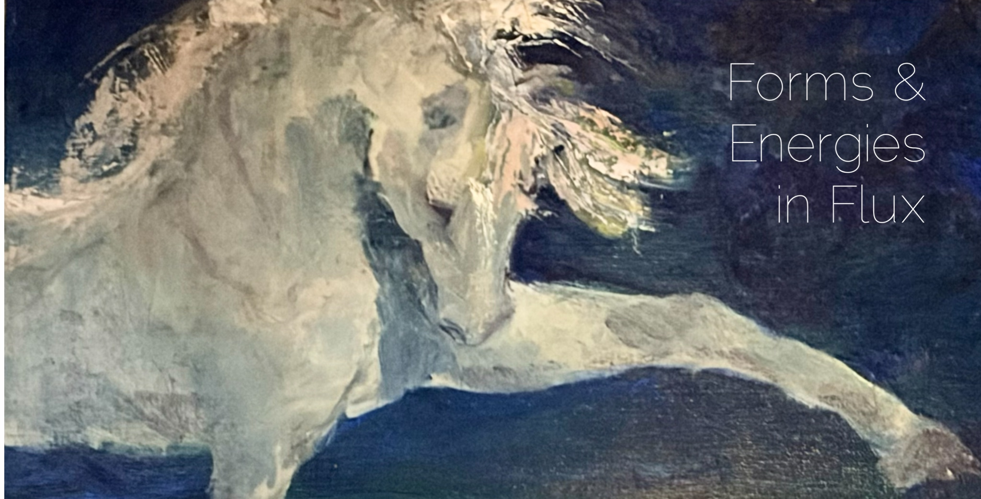
ARTIST RECEPTION AND DANCE PERFORMANCE, Sunday, September 6 at noon. A new art exhibit in the foyer, “Transformations: Forms & Energies in Flux,” will feature expressive oil paintings by Anne Tcherepnin, celebrated and award-winning painter, exploring light, landscape, and movement. You are invited to a special artist reception after the service that includes a live dance performance and projected dance films by choreographer Dunya McPherson, followed by a conversation with the artist. The exhibition will be on display in the foyer through October.

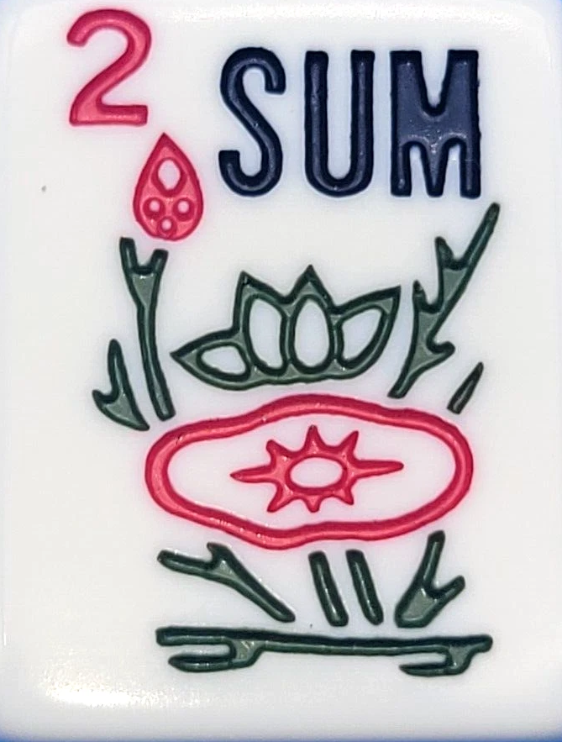
MAH JONGG FOR BEGINNERS - Have you ever wondered what all the rage is about Mah Jongg? Do you want to learn how to play? We meet every Tuesday from 1-3 PM at the Meeting House. Rosa Whiting and Cynthia Dyer have a Beginner-Beginner table and a Beginner table set up to help people learn the game. So, ladies and gents, come join us for this exciting game!

CONGREGATIONAL BREAKFAST, Sunday September 13 at 10 AM instead of the usual service. This Sunday, starting at 10 AM, there will be a Welcome Back Congregational Breakfast instead of the service. All are invited to bring a food item to share. Most importantly, come and celebrate the start of the new fellowship year!
Kids are welcome to bring their parents!

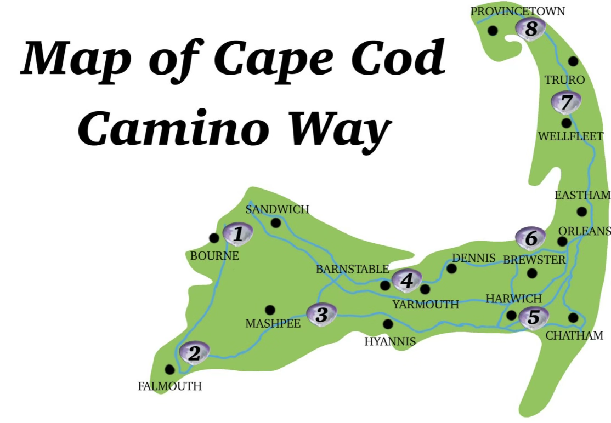
“CAPE COD CAMINO WAY: WALKING WITH A PURPOSE” - Wednesday, September 16 at 6:30 PM at the Meeting House and via Zoom. Over the summer of 2020, Peggy Jablonski walked through every town on Cape Cod, the peninsula she calls home, on a pilgrimage to reflect, listen, understand, and take action. The “Cape Cod Camino Way” is her story of asking questions, finding answers, and sharing what she has found. It is the story of building awareness toward true social justice action for the future.
You are invited to join Peggy as she shares stories and insights from her journey and encourages us to create a Camino Way walk of our own.
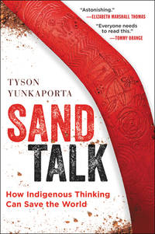
L.I.N.K. BOOK CLUB Invites UU Falmouth - Members of the UU Falmouth congregation are invited to join the L.I.N.K (Linking Indigenous and Non-Indigenous Knowledge) book group meeting on Friday, September 18 from 1:30-3:30 PM at the Meeting House. The book will be Sand Talk: How Indigenous Thinking Can Save the World, by Tyson Yunkaporta.
Aboriginal scholar, Yankaporta shows us what can be gained by viewing global systems through the lens of indigenous knowledge. He brings a crucial Indigenous perspective to history, education, money, power and sustainability. He uses sand talk, honoring an Aboriginal custom of drawing images on the ground to convey knowledge and ultimately help us better understand the world.
You are welcome whether or not you have read the book. Please email Marcia Smith at marciareadsmith@gmail.com if you’d like to join us.

SINGALONG WITH CAROLYN MCDADE - Saturday, September 19 at 2 PM at the Meeting House. Please join a singalong with Leona Bombaci and others who have sung with Carolyn McDade and her singing group for years. The event will be held via Zoom on the big screen at the Meeting House. It will include over a hundred women from the US and Canada who have sung with one another and Carolyn over the years. Song books will be available online. This is a transcendent experience as we join together singing music from the heart.

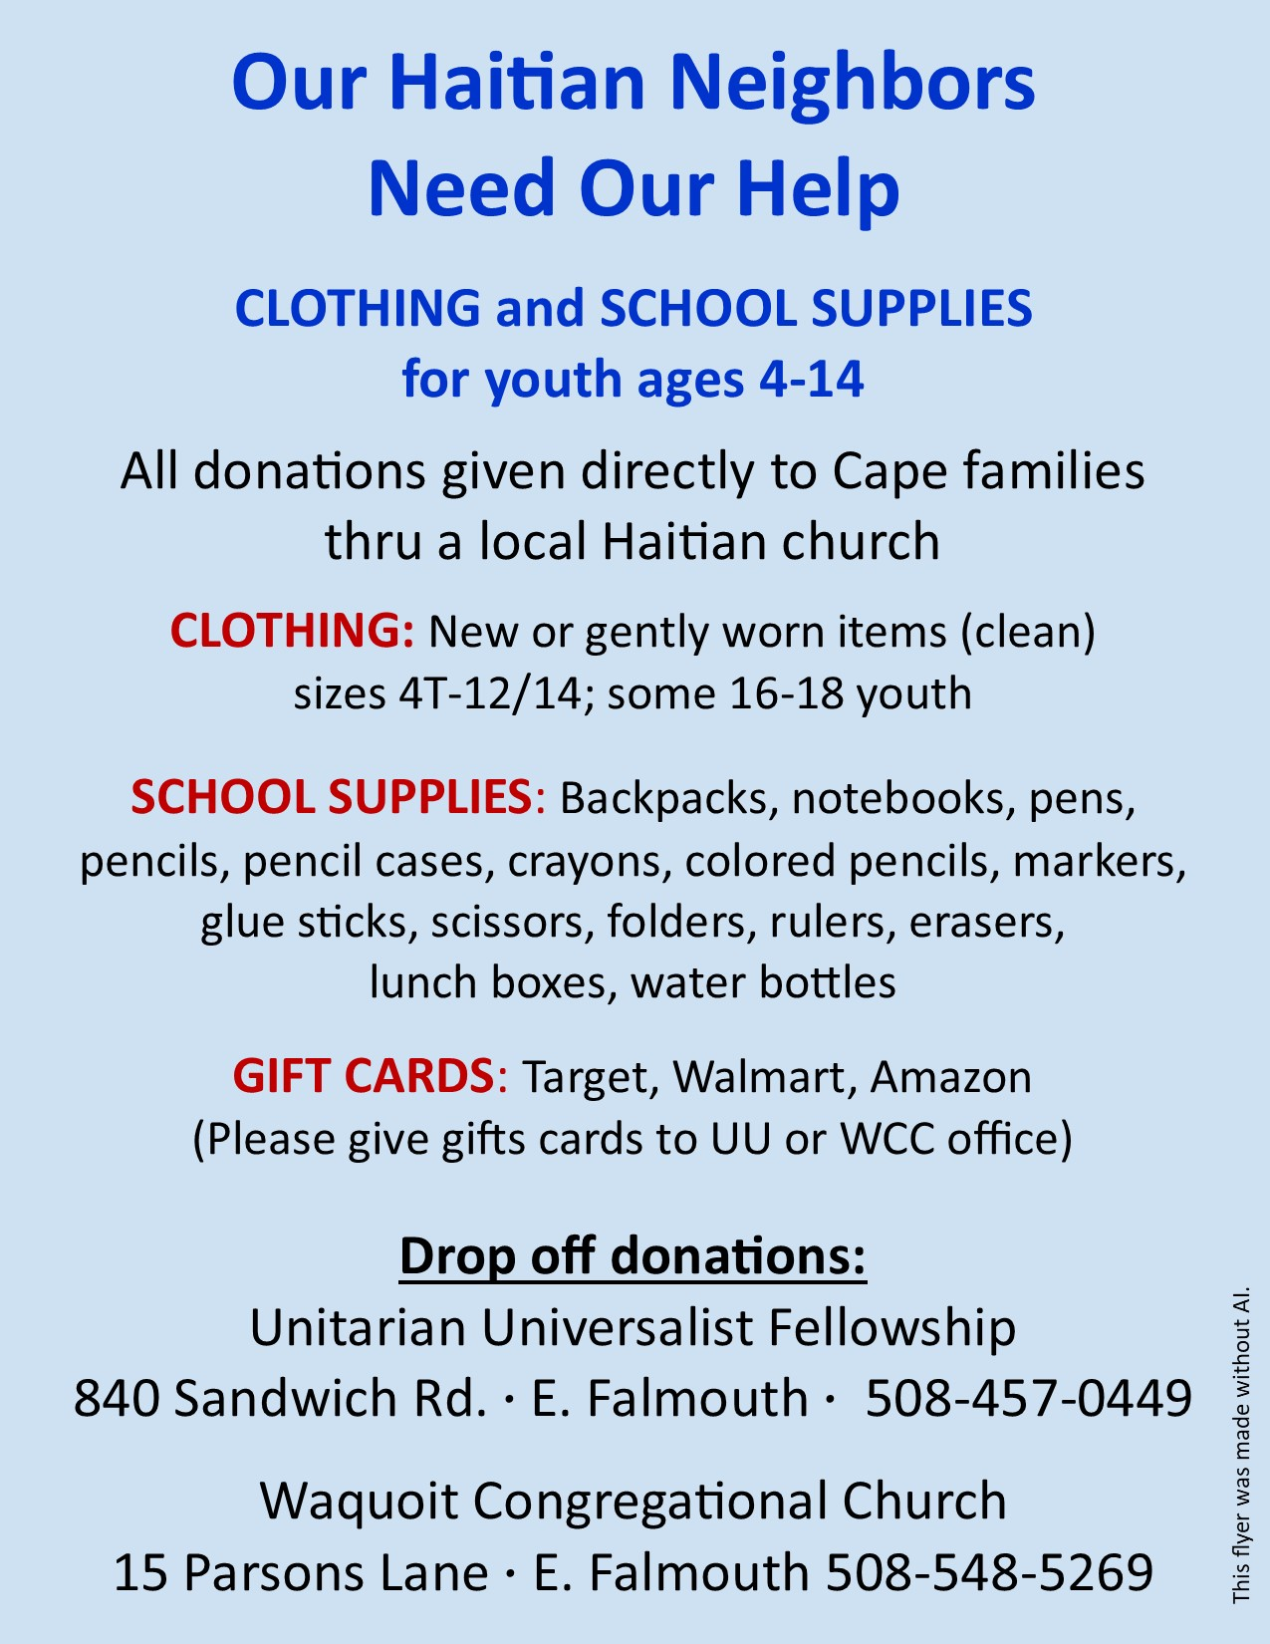
OUR HAITIAN NEIGHBORS NEED OUR HELP! UU Falmouth is partnering with the Waquoit Congregational Church to collect school supplies, gift cards, and clothing to be donated directly to families via a local Cape Cod Haitian church. Look for the flyer with more information in the foyer along with a collection box.
MEETING HOUSE CALENDAR
Red = Congregation-wide events open to all. Blue = Special Events
SUNDAY, September 6
10:00 AM Sunday Service
In Person and Zoom
11:15 AM Coffee Hour/Grocery cards
11:30 AM Sermon Discussion
12:00 PM Artist Reception/Dance
MONDAY, September 7
6:30 PM Choir Rehearsal
TUESDAY, September 8
8:00 AM Breakfast Bunch
11:00 AM Caring Committee
1:00 PM Mah Jongg
1:30 PM Fellowship Group #1
6:00 PM End Zone Reading Group
WEDNESDAY, September 9
9:30 AM Writing Time
1:00 PM Sit and Stitch
THURSDAY, September 10
8:00 AM Men’s Breakfast–Dave’s Barn
2:00 PM Chimes Ensemble
3:30 PM Fellowship Group #3
7:00 PM Finance Committee
FRIDAY, September 11
10:00 AM Writer’s Path
2:00 PM Community Circle
SUNDAY, September 13
10:00 AM CONGREGATIONAL BREAKFAST
MONDAY, September 14
6:30 PM Choir Rehearsal
7:00 PM SEAC Meeting
8:00 PM Music Committee
TUESDAY, September 15
8:00 AM Breakfast Bunch
1:00 PM Mah Jongg
6:00 PM End Zone Reading Group
WEDNESDAY, September 16
9:30 AM Writing Time
12:00 PM Brown Bag Book Bunch
1:00 PM Sit and Stitch
6:30 PM “Cape Cod Camino Way”
THURSDAY, September 17
8:00 AM Men’s Breakfast
10:15 AM B&G Meeting
2:00 PM Chimes Ensemble
7:00 PM Governing Board Meeting
FRIDAY, September 18
1:30 PM L.I.N.K. Book Club
6:30 PM Drumming Circle
SATURDAY, September 19
2:00 PM Carolyn McDade Singalong

