~ Week of September 20, 2021 ~

Click the link below to jump to the appropriate section.
- Chapter Updates & Meetings | - Opportunities for Action | - State House Update
- Elections Update | - Reading List | - Outdoors Connections

THIS WEEK’S FEATURED ACTIONS
Feature | Action | Contact
Fight for a National Climate Bill: Due to his tremendous power as Chair of the House Ways & Means Committee, Sierra Club and allies are targeting Rep Neal during this August recess. A huge issue in the fight for climate justice is the proliferation of fossil fuel subsidies, which Neal has the power to end through the End Polluter Welfare Act. | - If you’re in his district (MA01), use this tool to send a message now. (If you are not in his district, this tool will send a message to your congressperson, which is okay too!) | Jess N.

UPCOMING ADVOCACY HOUR EVENTS
Date | Event
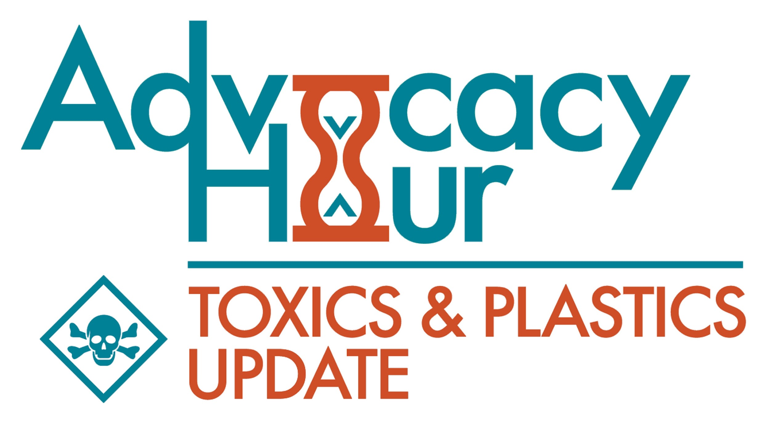  Wednesday, September 29 at 5pm | Clint Richmond, member of the Chapter Executive Committee & national Zero Waste Single-Use Plastics Subcommittee joins Advocacy Hour to present on recycling and zero waste. In particular, there will be a focus on plastics at the state and Federal level (Break Free From Plastic Pollution bill).
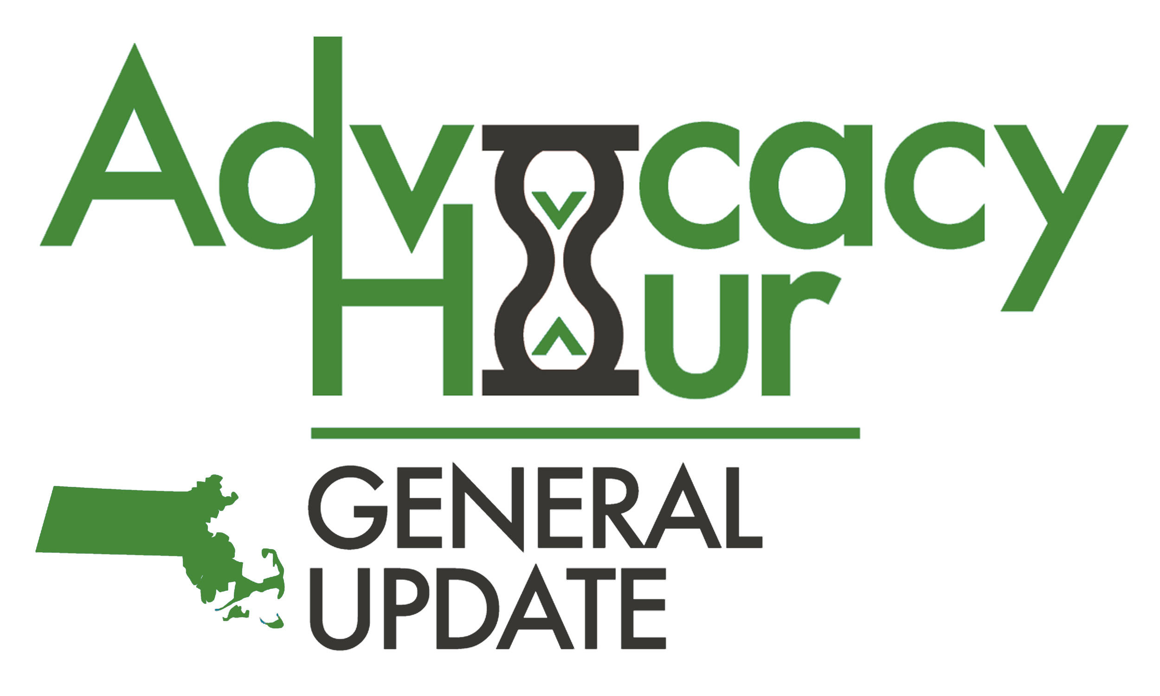  Wednesday, October 6 at 5pm | Join the chapter's Climate Research Team on October 6 for a presentation and update on their municipal climate research project. Across Massachusetts, individual cities and towns are taking action to fight climate change. These actions, referred to as municipal climate actions, are a key component to achieving the emissions reductions necessary for a safe future.
Click here to register for advocacy hour: sc.org/AdvocacyHour

CHAPTER UPDATES & MEETINGS
Run for the Sierra Club Executive Committee: The Sierra Club’s Massachusetts Chapter is recruiting members for our Executive Committee (ExCom), the volunteer-led governing body for the Chapter. This document explains the opportunities, responsibilities, and skills needed for the job. Interested candidates can submit materials by filling out this form. The deadline to submit materials is October 1, 2021.
Committee/Team • Click here for team descriptions | Contact
Executive Committee: The “ExCom” is the governing body of the Massachusetts Chapter. Voting members are volunteers who are elected for two year terms, but all are welcome to sit in on meetings.  Next meeting: October 21 at 5:30pm • contact Ben P. to attend | Ben P.
Cape Cod Group: Join the Cape Cod Group for their biweekly meeting. All interested parties are welcome.  Next meeting: September 28 at 7pm • contact Allyson S. to attend | Allyson S.
Political Committee: This committee researches political candidates and makes recommendations on who the Chapter should endorse. The meetings are confidential, so attendance is somewhat restricted.  Next meeting: September 28 at 6pm • sign up here to join the Political Committee | Vernon W.
Energy Committee: This committee meets monthly for conversations about energy policy. They weigh in on legislative issues, write testimony for hearings/public input sessions, and pen op-eds for media publications.  Next meeting: September 28 at 2:30pm • contact Paul D. to attend | Paul D.
Transportation Committee: This committee responds to critical transit issues affecting Massachusetts, including rail, bus, bike, pedestrian, and traffic pollution policies.  Next meeting: October 14 at 6pm • contact John K. to attend | John K.
Communications Team: The “comms” team handles the Chapter’s digital communications, including managing our social media accounts, sending email blasts, and other digital organizing tactics.  Next meeting: TBA • contact Emma B. for more info | Emma B.
Community Outreach Team: This team is responsible for person-to-person outreach to Sierra Club members and supporters. They use a variety of tools, including phone calling, peer-to-peer texting, and email blasts.  Next meeting: September 16 at 7pm • contact Laura B. to attend | Laura B.
PAC Team: This team is a standalone subgroup of the Political Committee. Their role is to raise funds for the Chapter’s PAC to increase our influence in state and local elections.  Meets semi-regularly • contact Mike S. for more info | Mike S.
Plant-Based Planet Team: This team raises awareness of the impact of animal agriculture. Their projects include developing a cooking show, hosting potluck dinners, and arranging educational events.  Next meeting: September 22 at 7 pm • contact Sara S. for more info | Sara S.
Toxics Team: This team handles toxic pollution issues, including deadly chemicals (e.g. PFAS), plastic-based pollutants, and recycling/solid waste issues. If you are interested in learning about toxics, doing research on toxics issues, or helping to raise awareness of toxics and plastics around the state, contact Deb.  Next meeting: October 4 at 5pm • contact Deb P. for more info | Deb P.
Climate Research Team: This team looks at municipal progress on clean energy/climate issues and seeks opportunities to leverage municipal power for state policy change.  Next meeting: **New Time** September 22 at 6pm • contact Emma B. to attend | Mallorie B.
Finance Advocacy Team: This team coordinates with others to educate and take action to stop support of the fossil fuel industry from banks, asset managers, and insurance companies.  No meeting scheduled • contact Cathy Z. for more info. | Cathy Z.
Forest Protection Team: The purpose of this team is to protect forests from human interference throughout Massachusetts to maximize carbon sequestration, promote biodiversity and optimize human health. Read more.  Next meeting: September 30 at 7:30pm • contact Lynne M. for more info. | Lynne M.
Boston Team: This team is working to advocate for climate-friendly policies in the city of Boston. Let’s make the largest city in New England a climate leader!  Next meeting: TBA • contact Michele B. for more info. | Michele B.
Fundraising Team: Have you ever wondered how to raise money for social causes? Do you like connecting with people? Do you believe that we need to redistribute wealth and power in order to build a just and vibrant economy and society? Do you like planning events or hiking to raise money? Fundraising is multifaceted and fascinating. At the Sierra Club, we are dedicated to fundraising to bring about meaningful social, racial, economic, and climate justice. Interested in any of this? Join the team! | Deb P.

OPPORTUNITIES FOR ACTION
Clean Energy & Climate | Action | Contact
The Mass Environmental Justice Table is hosting two legislative briefings this fall on two of its bills! These bills will provide guardrails to stop dirty transportation emissions and energy projects in Massachusetts’ environmental justice communities.  S.1447/H.2230 An Act to improve outdoor and indoor air quality for communities burdened by transportation pollution FACT SHEET  S.2135/H.3336 An Act Relative to Energy Facilities Siting Reform to Address Environmental Justice, Climate, and Public Health FACT SHEET | The Mass Environmental Justice Table is hosting two legislative briefings this fall on two of its bills!  Mon, October 4th 11AM - 12PM - Siting Justice: https://tinyurl.com/SitingJustice | Deb P.
Ready For 100: Energy 101 Training Series: Join the Ready for 100 campaign for a monthly training series all about energy! Sign up to attend the series, and be sure to visit Ready For 100’s Activist Toolkit to learn more about running a local campaign to transition your community to 100% clean energy. | Training #1 - Thursday, September 16th - Energy 101: What’s a watt and how did we get here?  Training #2 - Thursday, October 21st - Intro to the Grid and Utility System  Training #3 - Thursday, November 18th - What motivates an electric utility? How can we make them change?  Training #4 - Thursday, December 16th - Renewable Trends: Where is the industry going?  RSVP here for the training series | Michele B.
Say No to Woody Biomass: The Department of Energy Resources is still considering adding woody biomass to the Renewable Portfolio Standard. To do this would be an environmental travesty. | Send an email to the TUE Chairs, Jeffrey.Roy@mahouse.gov, and Mike.Barrett@masenate.gov demanding a hearing before August 5th on the proposed RPS changes. | Deb P.
MassSave Three-Year Plan Update in Process: The MassSave program is updated every three years, to include new incentives for improving efficiency and lowering the state’s greenhouse gas emissions. This is an $800 million dollar program, so it’s a huge deal, and we are now starting the public input process for the 2022 - 2024 3 Year Plan. This is one of the main avenues to lower building emissions in the Commonwealth. | After the Energy Efficiency Advisory Council provided input, the utilities will unveil their draft MassSave 2022-2024 3 Year Plan on April 30. Send a message demanding equity in the MassSave Program to the Energy Efficiency Advisory Council | Deb P.
Energy Justice Solar Revolution: What does it look like to scale up solar in a way that prioritizes those who bear the brunt of the pollution, cost, and disease impacts of our fossil fuel energy economy? | Read about this work in California to bring energy justice to communities through solar installations. | Deb P.
Climate Leadership Newsletter: We also share a once-a-month newsletter that features stories of environmental and climate action in Massachusetts. It provides a platform to highlight work being done by municipalities, climate leaders, and local groups in communities across the Commonwealth. Subscribe and view past versions here.
Transportation Matters | Action | Contact
MassDEP Action on Medium-and Heavy-Duty Vehicles: MassDEP will soon be initiating the regulatory process to address criteria pollutant, greenhouse gas, and toxic air contaminant emissions from medium- and heavy-duty (MHD) on-road vehicles. This includes the planned adoption of California’s medium-and heavy-duty (MHD) vehicle regulations including the Advanced Clean Truck (ACT) Rule, the Nitrogen Oxides Heavy Duty Omnibus, and the one-time large entity fleets reporting. Click here to read about the proposed regulations. Sierra Club’s advocacy toolkit has more information on the ACT Rule.  Public hearings on these regulations are expected in October. Sierra Club is working to ensure that the administration hears from a diverse group of stakeholders including residents, municipal officials, fleet operators, community and environmental justice groups. | Read about the proposed medium-and heavy-duty on-road vehicle actions here.  If you or sustainability and transportation groups in your community are interested in speaking up in support of these regulations, please email Veena Dharmaraj for talking points. Stay tuned for a webinar with more details on how you can engage. | Veena D.
Demand a stronger clean cars standards for cleaner air and climate action: The Environmental Protection Agency (EPA) has proposed a rule that should have drastically slashed emissions from the transportation sector, the largest source of carbon emissions in the US. However, the proposal is far too weak to achieve the climate progress we need, and contains loopholes that would allow auto manufacturers to continue to double down on gas guzzling vehicles. The proposal would result in much less pollution reduction than the auto industry agreed to in 2012, nearly a decade ago. Read the clean car factsheet and Sierra Club statement.  The clean cars rule is the single most important rule on greenhouse gas emissions in this country. We need your help strengthening it. Tell EPA we need a much stronger rule that offers no loopholes for automakers to delay the transition to all electric vehicles. | - Read Sierra Club’s statement  - Take Action: Tell EPA it must do better! (action alert)  - Clean Car Factsheet  - Use these talking points to write an LTE or op-ed.  - Amplify these tweets:  https://twitter.com/SierraClubLive/status/1430519219943247878  https://twitter.com/SierraClub/status/1425452505991983109 https://twitter.com/SierraClub/status/1425165733219258369 | Veena D.
Sierra Club’s Smart Growth and Infill Guidance Webinar Series: The Smart Growth and Infill Guidance provides meaningful guidance to activists in applying the Urban Infill Policy at the local level. It includes an overview of how land-use decisions get made, how to get involved in the process to ensure that urban infill policies are included in local plans and ordinances, what types of housing and transportation projects, plans, and policies we should support and oppose, and how to guarantee adequate and meaningful public participation, especially by historically underrepresented groups.  The guidance shows how general principles from the policy, such as that every neighborhood should be inclusive, compact and walkable, can be achieved across a spectrum of contexts, from single-family neighborhoods to transit corridors, and from rural towns to urban centers. Smarter growth is important in all of these settings, but what it looks like can vary considerably. | - Website: sc.org/infill  - One-pager on the Infill Guidance  - Webinars for staff and volunteers on the third Monday of each month at 8pm ET to walk through the guidance. RSVP here for one or more of the following sessions.  - Land Use and Infill - (September 20th - 8pm ET)  - Housing Access for All - (October 18th - 8pm ET)  - Active Transportation - (November 15th - 8pm ET)  - Resilience and Labor - (December 20th - 8pm ET) | Veena D.
National Drive Electric Week (NDEW): Join us from September 25 to Oct 3 for a nationwide celebration to raise awareness of the many benefits of electric vehicles. Attend one or many of the in-person events near you: Wellesley, Boston, Westborough, Lowell, Danvers, Andover, Plymouth | Click here for a list of online and in-person events. New events are added every week. | Veena D.
Join the NoProp22MA Rally for Worker Protections on October 6: Tech giants Uber, Lyft, DoorDash and Instacart have filed a proposal that would classify drivers for ride hailing and delivery apps as independent workers. This would allow tech giants to pay less than minimum wage and remove legal protections against workplace injuries, discrimination, and sexual harassment.  Sierra Club Massachusetts has endorsed the NoProp22MA campaign led by the Coalition to Protect Workers Rights to oppose this $100M big tech campaign. Read more about the proposal here and RSVP here to join the rally at the State House on Wednesday, October 6th at 10 AM. | Read the coalition press release here and here and help amplify this campaign video on social media.  RSVP here to join the rally on Wednesday, October 6th at 10 AM at the State House Steps in advance of the public hearing on the Uber/Big Tech bill. | Veena D.
Northampton Main Street for Everyone Campaign: The Main Street For Everyone campaign, is calling for significant improvements to the City of Northampton’s chosen redesign plan for Main Street in order to meet the climate emergency and economic changes facing downtown. This is a once-in-a-generation chance to reclaim Northampton’s greatest public space for more healthy and resilient public and economic activity including community gatherings, sidewalk vending, strolling, bicycling, performances, and the enjoyment of art and green space.  Visit MainSt4Everyone.org to learn about the design recommendations and how you can take action. Email mainst4e@gmail.com to help. | If you live or work in Northampton, write to Mayor Narkewicz (email template here) asking for a design that better addresses our climate emergency by significantly shrinking the street to make room for people and green infrastructure. | Veena D.
MOR-EV Rebate for Trucks: The Baker administration has expanded the MOR-EV program to include a $10 million commitment to fund electric medium-and heavy-duty vehicles. Rebate values vary by vehicle weight rating, ranging from $7,500 for pickup trucks up to $90,000 for tractor trailer trucks. Rebates decline over time and are available for public, private, and commercial fleets. Vehicles registered or operating in communities that meet the environmental justice income criteria are eligible for an additional 10% rebate. | Click here for details of the MOR-EV Rebate for Trucks  Share program details with municipal staff and local electeds in your community. | Veena D.
Volunteers Needed: Interested in writing a letter-to-the-editor (check out our writing guide)? Interested in writing a clean transportation guest blog post or volunteering to support the development of campaign material? Want to testify at the next FMCB meeting? Contact Veena Dharmaraj, (veena.dharmaraj@sierraclub.org).
Beyond Fossil Fuels | Action | Contact
MassCEC pilot showcases successes of Whole Home Heat Pumps | Read this blog! | Deb P.
New Harvard Study that shows that burning fossil fuels in buildings and other stationary sources costs MA $8.4 billion in health impacts every year.  The message is clear: to safeguard our health, we must stop burning fuels in buildings and go all-electric. | Visit RMI’s interactive map that shows the study’s data by state, and blog that can help answer faq’s about the study,  Watch the Chapter social media and amplify! | Deb P.
A Just Transition: “Those who have suffered from transitions [away from fossil fuels] are rarely the ones whose voices are heard. Yet, no one is more able to fully understand what workers and communities need than those who have lived that experience.”  To better understand how transition impacts people, what lessons can be learned, and what practices and policies must be in place for a just transition, the Labor Network for Sustainability launched the Just Transition Listening Project. | Listen to the Labor Network for Sustainability’s (LNS) Just Transition Listening Project’s findings:  Workers and Communities in Transition: Report of the Just Transition Listening Project. | Deb P.
DPU Docket 20-80: This DPU docket orders the utilities to write their own business plans for how they will comply with the states Global Warming Solutions Act’s emissions reductions targets (now 50% reduced by 2030, 75% by 2040 and net zero by 2050.  The Sierra Club is now designated as a stakeholder in this docket! | The report is due in March of 2022. There are a number of steps along the way. If you’d like to be a lead volunteer on this initiative, please reach out to Deb Pasternak. Join our communications team to raise awareness of the need to get off the gas system! | Deb P.
No Weymouth Compressor: Four gas releases have happened since it began operational. We will keep you posted on upcoming actions. | See and share thermal imaging of the compressor station operating. This FLIR camera shows heat where you could not see emissions otherwise. | Robert K.
Stop the Longmeadow Pipeline Project: Here is a petition about gas pipeline expansion through Longmeadow and Springfield. Please sign and share, especially if you live in Western MA | Click here to sign the petition. | Dave O.
Boston Based | Action
Building Emissions Performance Standard: The City of Boston has released a draft policy to accelerate decarbonization of buildings by setting new emissions reduction targets for buildings to meet, with the goal of being carbon free by 2050.  This is a central policy needed now in order to lower Boston’s carbon footprint and fight climate change! | Take action by sending a message to city leaders through our AddUp campaign here!  Sign a Green Justice Coalition petition for BEPS here! | Michele B.
Community Advisory Boards: The City of Boston has announced that they are seeking applications for a few community advisory boards. | Apply for the Community Advisory Board for Green Jobs Initiative here!  Apply for the Community Advisory Board for Wetlands Ordinance Phase III Regulations here!
BPDA Zero Net Carbon Zoning Initiative: This initiative will assess and identify strategies to strengthen green building zoning requirements to a zero net carbon standard for new construction. | The BPDA will be holding a public meeting on the development of the policy this spring. Sign up for updates and notices. | Michele B.
Sign up here to join the Boston volunteer team!
Toxics and Plastics | Action
No till, no GMO, no pesticides or herbicide, large scale farming. How to farm for healthy soils. | Watch a video here. | Deb P.
Artificial Turf is being pushed by industry as a cheaper and environmentally friendly solution. | Read here to learn about the issues with this toxic product. | Deb P.
It's rainy and it is summer, which means mosquito spraying is in season. Check out your county's spraying schedule and how to request exemption. | Attend the Mosquito Control Task Force Meeting on July 27. | Deb P.
The Pesticide Board Subcommittee is meeting to discuss Fluorinated Pesticides on September 21 at 9 am. They will be discussing Clint Richmond’s comment and recommendations on how to regulate these toxic chemicals. | Attend the meeting on September 21, at 9 am. Although not posted yet, the link to register will appear here. | Deb P.
Maine Governor Signs into Law Groundbreaking Restrictions on PFAS in products. Read about this here. | Contact your legislators and tell them to talk to the Public Health Committee Chairs to pass meaningful PFAS regulatory laws this session. | Deb P.
Toxics Use Reduction: The fifth meeting of the Toxics Use Reduction Advisory Committee (TURA) Program Strengthening Ad Hoc Committee will be dedicated to the TURA List of Toxic or Hazardous Substances. | Read the notes about their decision to update PFAS classification in the meeting minutes from July 22, 2021. | Deb P.
Toxics Team: Team members have been helping us to research the dozens of products that are proposed for state use every month. | Check out our notes from our latest meeting! | Deb P.
MassDEP Solid Waste Advisory Committee (SWAC) Meeting: The Massachusetts Department of Environmental Protection (MassDEP) is scheduling a meeting of the Solid Waste Advisory Committee (SWAC) to review, discuss, and obtain feedback on potential changes to MassDEP’s solid waste regulations. Feedback on these proposed changes will be used to inform the development of draft regulations to be issued for public comment later in 2022. You are invited to attend the Zoom meeting on September 21, 2021, 10:00 AM – 12:00 PM ET. MassDEP will also send a summary of the proposed changes out to registered attendees prior to the meeting. This summary will also be shared as part of the meeting materials posted online following the meeting. | MassDEP is requiring registration for this meeting. After registering, you will receive a confirmation email containing information about joining the meeting. | Emma B.
Plastics, dirty in production, recycling, and discarding, are a growing problem. Watch “The Story of Plastic” and then work to ban types of disposable plastics in your community or statewide.

Protect the Planet and Natural Resources
Learn about why Sierra Club stands with First Nations people against importing electricity from Canadian megadams. | Read an essay from Atlantic (New York) Chapter leader, Kate Bartholomew, here. | Deb P.
Save Massachusetts Forests and Climate Action Now present a series: Protecting Massachusetts Forests in the Time of a Climate Emergency. | Watch the webinar: Alosada Kpiwi - Let's Walk in the Woods with Rich Holchuh - June 15, 2021 | Lynne M.
Forests v. Solar: A False Choice | Watch the video and learn why forests are so important and must be preserved. | Lynne M.
Meanwhile in Washington D.C. | Action | Contact
Change Powered By People - Summer of Collective Action: We believe that change is powered by people -- that this country belongs to all of us, and we hold the power to create a future where we all can thrive. Right now, Congress has a once-in-a-generation opportunity to shape our society and economy by passing two pieces of legislation: an infrastructure package to tackle climate change, create jobs, and address racial injustice; and bold democracy reforms like the For the People Act and John Lewis Voting Rights Act. This August Recess, when our members of Congress are back home to hear from their constituents, we’ll make it clear that we will accept nothing less than a fully functioning democracy and an economy that sustains both people and the planet. The stakes are too high to sit this one out. Let’s do this! | Fight for a National Climate Bill: Due to his tremendous power as Chair of the House Ways & Means Committee, Sierra Club and allies are targeting Rep Neal during this August recess. A huge issue in the fight for climate justice is the proliferation of fossil fuel subsidies, which Neal has the power to end through the End Polluter Welfare Act.  If you’re in Rep Neal’s district (MA01), use this tool to send a message now. (If you are not in his district, this tool will send a message to your congressperson, which is okay too!) | Emma B.
Stand in Solidarity | Action | Contact
Solidarity with the Gulf South: On the 16th anniversary of Hurricane Katrina, the Gulf South experienced another climate disaster in Hurricane Ida. The Gulf Coast Center for Law and Policy, a grassroots organization fighting for structural shifts toward ecological equity and climate justice in Gulf South communities of color on the frontline of climate change, is working with partners and communities to assess the immediate and long-term impacts of the storm. If you want to support their efforts, you can donate to a community-controlled rapid response fund led by those at the frontline of recovery. https://bit.ly/StormReliefFund | Please consider making a donation if you are able to. bit.ly/StormReliefFund | Emma B.
Solidarity with Black Lives: The Sierra Club Massachusetts Chapter is committed to being an actively anti-racist organization. Climate justice and racial justice are inextricably linked, which is why we will continue to learn from and fight alongside racial justice organizations. There will be no climate justice while Black, Indigenous, Asian, and Latinx people and communities in this country fear for their lives every time they get in the car, go to the store, leave their homes, or simply sleep in their own beds. | Please take a moment to consider how you can continue to learn and grow toward being more actively anti-racist and anti-oppressive. We are continually adding to the Anti-Racism Resources page on our website.  Learn  - Don't Call the Police  - Anti-racism resources  Take Action  - Campaign to End Qualified Immunity  - Mass Action Against Police Brutality  Support  - Black Visions MN  - Rochester Community Initiative | Emma B.
Decriminalize Fare Evasion and Implement Discounted Fare System: Tell the T to stop over policing black and brown riders by signing on to this petition from our allies at Alternatives for Community and Environment (ACE). Black and Latinx riders on the subway account for almost two-thirds of fare-evasion citations from police -- despite being just one-third of subway riders | Sign the petition | Veena D.
Partner Events | Action | Contact
Put Peakers in the Past: Weekly standout: There are three peaking power plants in Berkshire County, MA: Woodland Road in Lee, and Doreen and Pittsfield Generating in Pittsfield. These plants are decades old and run on highly polluting fossil fuels, including “natural” gas, fuel oil and kerosene. They endanger health in the local neighborhoods and cost ratepayers tens of millions per year despite only running a fraction of the time. Join the Putting Peakers in the Past Coalition every week for a standout to demand that the three peaking power plants located in Berkshire County, MA convert to only renewable and clean alternatives. | Join the standout: Saturday mornings  10:30 - 11:30 am  Dalton Rd. Plaza, Pittsfield, across from Plastics Ave. | Emma B.
Pulling the curtain back on The Hydrogen Hoax at Pittsfield Green Drinks: Gas utility companies, like Berkshire Gas and Eversource, see the writing on the wall with new climate goals in Massachusetts and nationally. In the “fight for their lives,” they plan on piping hydrogen, an expensive, explosive gas, most often produced with fossil fuels, into our homes and buildings for heating, cooking and hot water.  Cathy Kristofferson from the Pipe Line Awareness Network for the Northeast (PLAN) joins the Berkshire Environmental Action Team (BEAT) to talk about one of climate change's most popular misconceptions about using hydrogen as an energy source (and how industry is hyping false solutions) and the future of clean renewable energy for Massachusetts. | We’ll explain what the gas utilities plan on doing and why it isn’t safe, affordable, equitable, clean, green, or the solution we need for a clean renewable energy future.  September 21 at 6:00pm  Register here | Deb P.
Massachusetts Climate Action Network releases and explains their Municipal Light Plant scorecard  We will review our methods, the ranks and scores of MLPs in key performance areas, and discuss MCAN’s recommendations for making MLPs a leader in energy efficiency, energy transition, transparency and community engagement. | Sept 23, 6pm  https://us02web.zoom.us/meeting/register/tZEkc-2uqjIvH9R-MTrE9HSxU7C7XmhmN9_4 | Jess N
Youth-led intergenerational rally  This is a collaborative, youth-centered, intergenerational event organized by members of the Massachusetts Youth Climate Coalition (MYCC) and their adult allies. The effort is led by Fridays for Future MA, in concert with other strikes occurring around the world on the same day. | September 24th, starting at 3 pm  Where: starting at the Boston Public Garden  RSVP Here | Jess N
Creating a Zero Waste Kitchen with the Founders of Food Waste Feast: Right now, most of New England’s food scraps are being buried in landfills, which produces methane, a climate-damaging emission. Landfills accepting our food waste and curbside trash are the third-largest source of harmful methane emissions in the United States.  To see how we can cut down on our own food waste, CLF is partnering with Food Waste Feast to host a live, virtual event on September 27 at 3:00 PM. Co-founders Mei and Irene will join us from their home kitchens to share a few tips and tricks on how to cut down food waste – and save money. Plus, the sister-duo, who also co-founded Mei Mei Dumplings in Boston, will answer all your zero-waste foodie questions. | Creating a Zero Waste Kitchen  Featuring the Founders of Food Waste Feast  September 27, 2021  3:00 PM to 3:45 PM  RSVP here | Emma B.
Love. Earth. Justice.  At 3 pm on Sunday, October 3, 2021, Massachusetts Interfaith Power & Light will convene Love. Earth. Justice.: A Multifaith Service of Prayer, Celebration, and Resolve. We will gather at Old South Church in Boston to celebrate creation and community, mourn all we have lost, and call each other to faithful action. Planned for approximately 90 minutes, the service will include prayer, meditation, and uplifting music, with an inspiring sermon from Rev. Traci Blackmon, national justice minister for the United Church of Christ. We’ll follow the strict Covid protocols of Old South Church. | October 3, 2021, 3-4:30 pm  Gather at Old South Church,  Wherever you live, you can join by livestream. Complete information is at www.massipl.org/love-earth-justice.

STATE HOUSE UPDATE
Legislation We’re Tracking | Current Status/Action | Contact
Support the Public Lands Preservation Act: This bill would further codify the current state policy that there be no net loss of lands or easements protected under Article 97. It would require that replacement land of comparable acreage and natural resource value be provided for each disposition. A previous version of this bill passed the House in the 191st session, but was not taken up in the Senate. Check out our fact sheet here (updated 8/23/2021). | Our PLPA campaign needs support in the digital world! Please email a short (30 seconds or less) video about why you support preserving public lands to emma.brown@sierraclub.org! Bonus points if you film it *on* publicly owned land. | Emma B.
Legislative Priorities: We’ve announced our top priorities for the 2021-2022 legislative session. | Send this page to your legislators and ask them to co-sponsor our top priority bills! | Jess N.
Resources:
- CSSN Research Report 2021: Who’s Delaying Climate Action in Massachusetts? Twelve Findings (Jan 2021)
- Video: How the legislature works by Beacon BLOC (1/15/21)

ELECTIONS UPDATE
Update | Action | Contact
September Primary Races: Municipal elections are happening this year, with primary races happening in September for many cities and towns. | Take a look at our Chapter endorsed candidates and don’t forget to vote! | Jess N.

READING LIST
Check Out What We’ve Been Reading - News from Massachusetts and Beyond

- Biden Confronts Extreme Heat, A Silent Climate Killer (Washington Post, 9/20/21)
- Building Electrification Could Recharge Our Economy and Save the Climate (Forbes, 9/20/21)
- This powerful Democrat linked to fossil fuels will craft the US climate plan (Boston Globe, 9/20/21)
- As Climate Change Fears Grow, A Real Fight Over Fake Turf (New York Times 9/18/21)
- House Panel Expands Inquiry Into Climate Disinformation by Oil Giants (New York Times, 9/16/21)
- Nantucket airport lawsuit blames chemical companies for PFAS Contamination and Wants them to Pay (Cape Cod Times, 9/16/21)
- Alabama PFAS Manufacturing Plant Creates the Climate Pollution of 125,000 Cars (EHN, 9/16/210
- What’s In The Latest Version of House Dem’s proposed Clean Energy Legislation (Canary Media, 9/16/21)
- Climate Investments Can’t Wait (Boston Globe, 9/13/21)
- California Aims to Ban Recycling Symbols on Things Which Aren’t Recyclable (NY Times, 9/8/21)
- These Lawmakers Wrote the Climate Bill. They’re Worried The State Won’t Achieve It. (Boston Globe, 9/7/21)
- It is Time for Everyone to Have a Healthier Home, (The Hill, 8/31/21)
- Curb Boston’s Biggest Source of Greenhouse Gas Emissions (Boston Globe, 8/30/21)
- Heat pumps could be key to fighting climate change, but how? We answer your burning questions (Boston Globe, 8/25/21)
- Massachusetts Should be Converting 100,000 homes a year to electric heat. The actual number: 461 (Boston Globe, 8/20/21)
- 'Personal Choice' Won't Stop The Climate Crisis. Join A Movement Instead (WBUR, 8/19/21)
Resources
- Ready for 100 Organizing Toolkit: Learn to organize your community for climate and environmental initiatives! The Ready For 100 campaign has spent the last year compiling everything they know about how to build local power to win local clean energy victories into an activist toolkit.
- Learn about the issues with Carbon Offsets: These Trees Are Not What They Seem

CONNECTING WITH THE OUTDOORS
Activites | Action | Contact
Watch “Judi Dench My Passion for Trees” a wonderful and effective film about the value of trees.

